After FAQ, put ….

0.25 min

1. Opening

*2 min

1. Motivation
2. Facts (unmet clinical need)

* Millennium Development Goal 5 (MDG 5)
* 99% of maternal deaths happen in developing countries
* Every day, 830 women die from preventable causes related to pregnancy and childbirth
* !!287 000 women died in 2010 during pregnancy or childbirth
* The key obstacle is pregnant women's lack of access to quality skilled care before, during and after childbirth.
* Telemedicine may assist… (literature survey)

1. Limitation of telemedicine in resource scarce area

* Lack of resource (electricity, internet, lab sample delivery, communication, medical professional)
* Cost

1. Proposed solution

* UAV based portable prenatal kit… (advantages of UAV, comparison… half page)
* Screening for the group of high risk
* To our best knowledge, this is the first attempt to develop UAV carried telemedicine device for prenatal care

1. Specific aims //add a box of “Balance, trade off…”

* To offer the critical measurements of health care during pregnancy
* Light-weight
* Self-sustaining
* Low-cost
* Easy to operate
* Tele-medicine

1. //one page of our challenge
   1. min
2. Proposed operating model

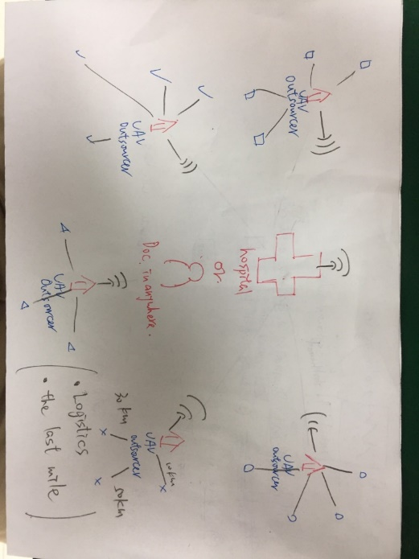

1.25 min

1. Prototype (Design Architecture)
2. Key measurements

* Weight
* Blood pressure
* Fetal heart rate
* Video conference (問診)

1. (to screen for …)

* Gestational hypertension
* Gestational diabetes
* Pre-eclampsia and eclampsia
* No fetal heart rate //official name
* Not normal weight gain //official name
* Not normal SFH //official name
* Anemia
* Asymptomatic Bacteuria

1. Implementation
2. Instruments (Hardware)

* Rpi 3, arduino (cheap, full-functioning, small-size)
* Modulized instruments (IoT, convenient, safe, easy accessible components, easy to be maintained)
* UAV
* RFID for patient identification
* Cost list
* Weight/size list

1. Service (Software) **(Put emphasis on this)**

* Design Concept… (environment of development, C#, Python3, Qt4, Ozeki, Live chart)
* Google cloud
* **Smart Diagnosis

1. Result (demo video)
   1. min
2. Discussion //no discussion
3. Progress of our design (Humble but confident…
4. Potential to reach the market
5. Potential benefits
6. Digitized medical record
7. Cloud – data collection portal

* Deficiency of data collection in remote areas
* -> for future AI research (big data analysis)
* -> ??for precision medicine

Epidem(流行病學), public health

* 1. min

1. Future improvements
2. Cellular 3G/4G - > satellite

* Coverage

1. Hardware and software optimization
2. Instruments

* EKG //uterine contraction cycle
* Ultrasound
* Blood sampling //reference a picture of TAPS, faa approval

1. Potential applications

* Newborn health examination
* Chronic disease in elders
* Emergency medical service (ex. Drug delivery)
* Portable device for physicians

1. Conclusion
2. FAQ

補充資料

人次成本計算表

Total time: 10 min